A Survey of Augmented Reality
(…)
At least six classes of potential AR applications have been explored: medical visualization, maintenance and repair, annotation, robot path planning, entertainment, and military aircraft navigation and targeting. The next section describes work that has been done in each area. While these do not cover every potential application area of this technology, they do cover the areas explored so far.
2. Applications
2.1 Medical
Doctors could use Augmented Reality as a visualization and training aid for surgery. It may be possible to collect 3-D datasets of a patient in real time, using non-invasive sensors like Magnetic Resonance Imaging (MRI), Computed Tomography scans (CT), or ultrasound imaging. These datasets could then be rendered and combined in real time with a view of the real patient. In effect, this would give a doctor "X-ray vision" inside a patient. This would be very useful during minimally-invasive surgery, which reduces the trauma of an operation by using small incisions or no incisions at all. A problem with minimally-invasive techniques is that they reduce the doctor's ability to see inside the patient, making surgery more difficult. AR technology could provide an internal view without the need for larger incisions.
AR might also be helpful for general medical visualization tasks in the surgical room. Surgeons can detect some features with the naked eye that they cannot see in MRI or CT scans, and vice-versa. AR would give surgeons access to both types of data simultaneously. This might also guide precision tasks, such as displaying where to drill a hole into the skull for brain surgery or where to perform a needle biopsy of a tiny tumor. The information from the non-invasive sensors would be directly displayed on the patient, showing exactly where to perform the operation.
AR might also be useful for training purposes [Kancherla95]. Virtual instructions could remind a novice surgeon of the required steps, without the need to look away from a patient to consult a manual. Virtual objects could also identify organs and specify locations to avoid disturbing [Durlach95].
Several projects are exploring this application area. At UNC Chapel Hill, a research group has conducted trial runs of scanning the womb of a pregnant woman with an ultrasound sensor, generating a 3-D representation of the fetus inside the womb and displaying that in a see-through HMD (Figure 2). The goal is to endow the doctor with the ability to see the moving, kicking fetus lying inside the womb, with the hope that this one day may become a "3-D stethoscope" [Bajura92] [State94]. More recent efforts have focused on a needle biopsy of a breast tumor. Figure 3 shows a mockup of a breast biopsy operation, where the virtual objects identify the location of the tumor and guide the needle to its target [State96b]. Other groups at the MIT AI Lab [Grimson94] [Grimson95] [Mellor95a] [Mellor95b], General Electric [Lorensen93], and elsewhere [Betting95] [Edwards95] [Taubes94] are investigating displaying MRI or CT data, directly registered onto the patient.
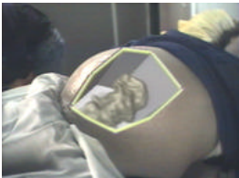
Figure 2: Virtual fetus inside womb of pregnant patient. (Courtesy UNC Chapel Hill Dept. of Computer Science.)
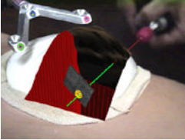
Figure 3: Mockup of breast tumor biopsy. 3-D graphics guide needle insertion. (Courtesy UNC Chapel Hill Dept. of Computer Science.)
2.2 Manufacturing and repair
Another category of Augmented Reality applications is the assembly, maintenance, and repair of complex machinery. Instructions might be easier to understand if they were available, not as manuals with text and pictures, but rather as 3-D drawings superimposed upon the actual equipment, showing step-by-step the tasks that need to be done and how to do them. These superimposed 3-D drawings can be animated, making the directions even more explicit.
Several research projects have demonstrated prototypes in this area. Steve Feiner's group at Columbia built a laser printer maintenance application [Feiner93a], shown in Figures 4 and 5. Figure 4 shows an external view, and Figure 5 shows the user's view, where the computer-generated wireframe is telling the user to remove the paper tray. A group at Boeing is developing AR technology to guide a technician in building a wiring harness that forms part of an airplane's electrical system. Storing these instructions in electronic form will save space and reduce costs. Currently, technicians use large physical layout boards to construct such harnesses, and Boeing requires several warehouses to store all these boards. Such space might be emptied for other use if this application proves successful [Caudell92] [Janin93] [Sims94]. Boeing is using a Technology Reinvestment Program (TRP) grant to investigate putting this technology onto the factory floor [BoeingTRP94]. Figure 6 shows an external view of Adam Janin using a prototype AR system to build a wire bundle. Eventually, AR might be used for any complicated machinery, such as automobile engines [Tuceryan95].
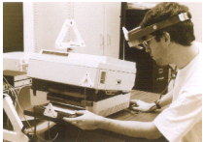
Figure 4: External view of Columbia printer maintenance application. Note that all objects must be tracked. (Courtesy Steve Feiner, Blair MacIntyre, and Dorée Seligmann, Columbia University.)
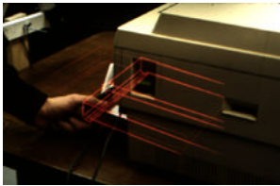
Figure 5: Prototype laser printer maintenance application, displaying how to remove the paper tray. (Courtesy Steve Feiner, Blair MacIntyre, and Dorée Seligmann, Columbia University.)
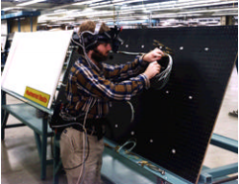
Figure 6: Adam Janin demonstrates Boeing's prototype wire bundle assembly application. (Courtesy David Mizell, Boeing)
2.3 Annotation and visualization
AR could be used to annotate objects and environments with public or private information. Applications using public information assume the availability of public databases to draw upon. For example, a hand-held display could provide information about the contents of library shelves as the user walks around the library [Fitzmaurice93] [Rekimoto95a] [Rekimoto95b]. At the European Computer-Industry Research Centre (ECRC), a user can point at parts of an engine model and the AR system displays the name of the part that is being pointed at [Rose95]. Figure 7 shows this, where the user points at the exhaust manifold on an engine model and the label "exhaust manifold" appears.
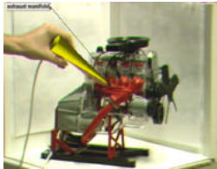
Figure 7: Engine model part labels appear as user points at them. (Courtesy ECRC)
Alternately, these annotations might be private notes attached to specific objects. Researchers at Columbia demonstrated this with the notion of attaching windows from a standard user interface onto specific locations in the world, or attached to specific objects as reminders [Feiner93b]. Figure 8 shows a window superimposed as a label upon a student. He wears a tracking device, so the computer knows his location. As the student moves around, the label follows his location, providing the AR user with a reminder of what he needs to talk to the student about.
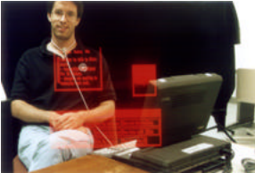
Figure 8: Windows displayed on top of specific real-world objects. (Courtesy Steve Feiner, Blair MacIntyre, Marcus Haupt, and Eliot Solomon, Columbia University.)

